Question 1
Create a NumPy array containing the integers from 1 to 20. Perform the following operations:
1. Display the array.
2. Find the shape of the array.
3. Find the maximum and minimum values.
4. Calculate the mean and standard deviation.
5. Reshape the array into a 4 × 5 matrix.
6. Display the second row of the matrix.
7. Display the third column of the matrix.

CODE:
import numpy as np
num = np.arange(1,21)
print("array:", num)
print("shape:", num.shape)
print("maximum :", num.max())
print("minimum:", num.min())
print("mean:", num.mean())
print("standard deviation:", num.std())
matrix = num.reshape(4,5)
print(" 4/5 matrix :", matrix)
print("second row", matrix[2])
print("third coloum :", matrix[:,3])

OUTPUT:

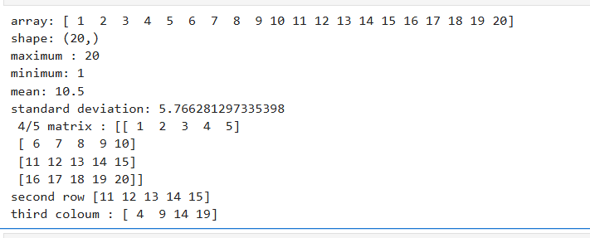

Question 2
Create two NumPy arrays:
A = [10, 20, 30, 40, 50] , B = [5, 10, 15, 20, 25]
Perform: 1. Addition of A and B.
2. Subtraction of B from A.
3. Element-wise multiplication.
4. Element-wise division.
5. Find the sum of all elements in A.

CODE:
import numpy as np
A = np.array([10,20,30,40,50])
B = np.array([5,10,15,20,25])
print(A),print(B)
print("Addition:", A+B)
print("sub:", A-B)
print("mult:", A*B)
print("div:", A/B)
print("sum of all elements in A", A.sum())
OUTPUT:
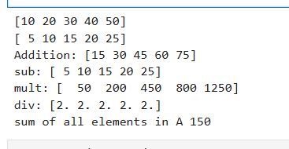

Part B –
Pandas Question
3 Create a DataFrame using the following student data:
Roll No 101 102 103 104 105
Name Ravi Priya Kiran Anu Sita
Marks 85 92 78 88 95
Perform the following operations:
1. Display the DataFrame.
2. Display the first three records.
3. Find the average marks.
4. Find the student with the highest marks.
5. Find the student with the lowest marks.
6. Add a new column called "Grade" using: o A for Marks ≥ 90 o B for Marks between 80 and 89 o C for Marks < 80

CODE:
import pandas as pd
data = {"Roll No":[101,102,103,104,105],
"Name":["Ravi","priya","kiran","Anu","Sita"], "Marks":[85,92,78,88,95]
}

df = pd.DataFrame(data)
print(pd)
print("display first three records:")
print(df.head(3))
print("average marks:", df["Marks"].mean())
print("student with highest marks:")
print(df.loc[df["Marks"].idxmax()])
print("student with lowest marks:")
print(df.loc[df["Marks"].idxmin()])
def grade(Mark):
if Mark >= 90:
return "A"
elif Mark >= 80:
return "B"
else:
return "c"
df["grade"] = df["Marks"].apply(grade)
print("dataframes with grades :")
print(df)

OUTPUT:

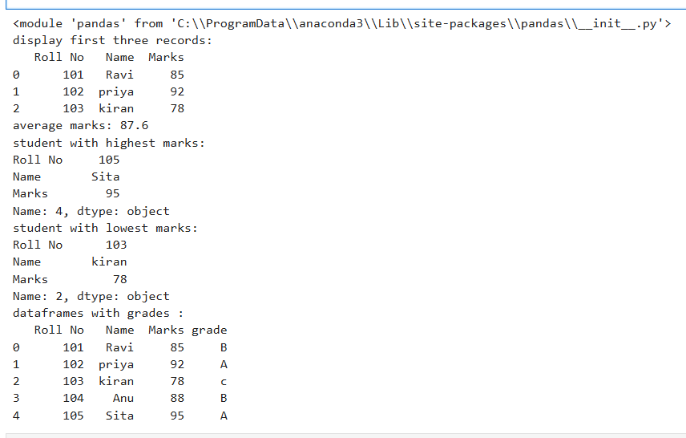

Question 4
Create a DataFrame containing the following information:
Product Price Quantity
Laptop 50000 10
Mouse 500 50
Keyboard 1200 30
Monitor 10000 15
Perform: 1. Calculate the total value of each product using:
Total Value = Price × Quantity
2. Add the Total Value column.
3. Find the product with the highest total value.
4. Calculate the overall inventory value.

CODE:
import pandas as pd

data = {"Product":["Laptop","Mouse","Keyboard","Monitor"],
"price":[50000,500,1200,10000], "Quantity":[10,50,30,15]
}
df = pd.DataFrame(data)
df["total value"] = df["price"] * df["Quantity"]
print("product with highest value:")
print(df.loc[df["total value"].idxmax()])
print("overall inventory value:",df["total value"].sum())

OUTPUT:
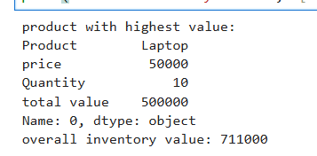

Part C – Dataset Exploration Question
5 Download the Iris dataset from Scikit-learn and perform the following:
1. Load the dataset into a Pandas DataFrame.
2. Display the first five records.
3. Find the number of rows and columns.
4. Display column names.
5. Check for missing values.
6. Generate summary statistics using describe().
7. Find the number of samples belonging to each class.

CODE:
import pandas as pd
from sklearn.datasets import load_iris
iris = load_iris()
df = pd.DataFrame(iris.data, columns=iris.feature_names)
df["target"] = iris.target
print("First Five Records:")
print(df.head())
print("\nRows and Columns:", df.shape)
print("\nColumn Names:")
print(df.columns)
print("\nMissing Values:")
print(df.isnull().sum())
print("\nSummary Statistics:")
print(df.describe())
print("\nSamples in Each Class:")
print(df["target"].value_counts())

OUTPUT:
